**Schema and Tables**

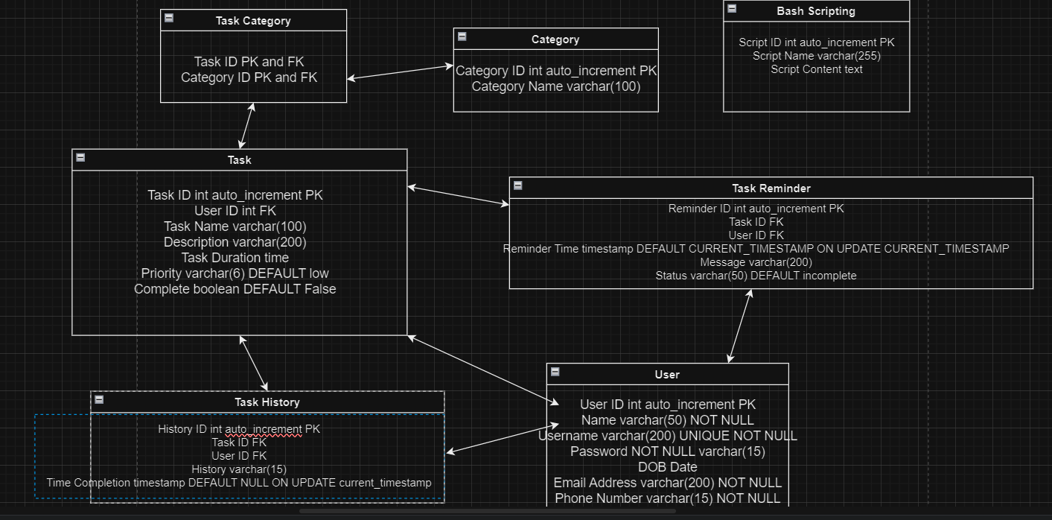

**DDL COMMANDS**

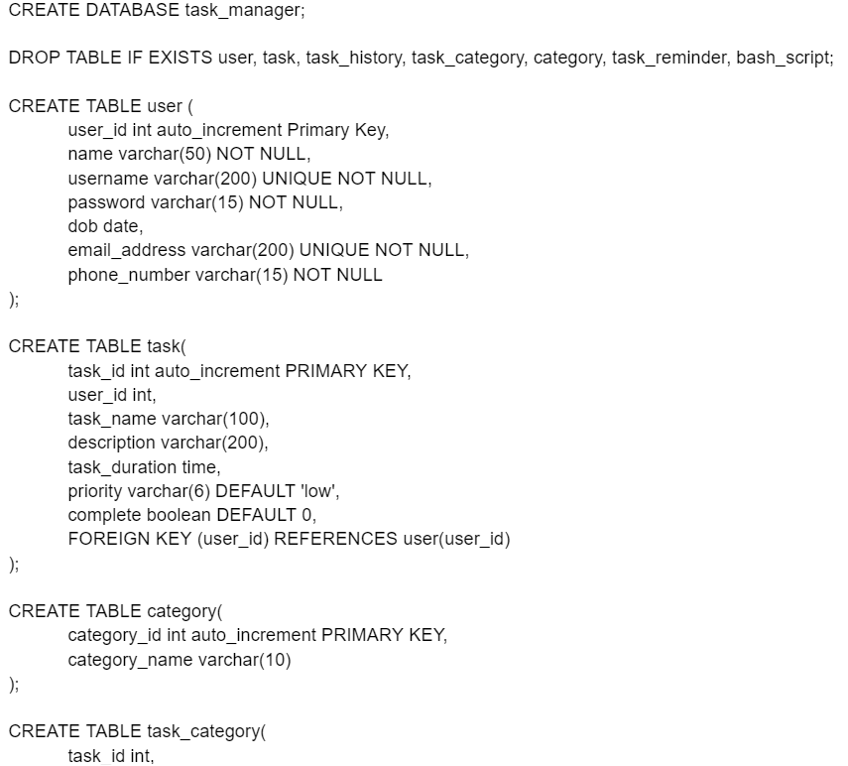

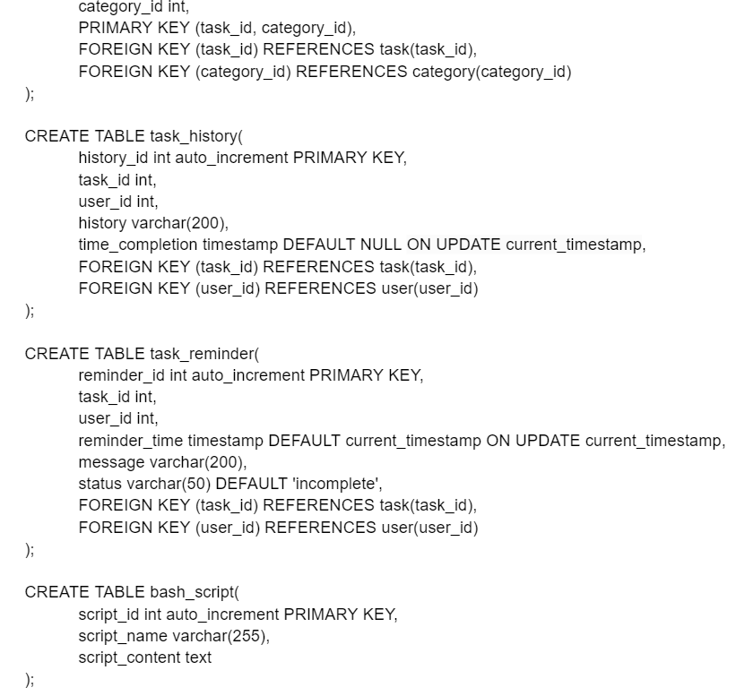

**Stored Procedures**

**Creating a new user**

DELIMETER//

CREATE PROCEDURE create_user(

-> IN name VARCHAR(50),

-> IN username VARCHAR(200),

-> IN password VARCHAR(64), -- Change the length to match the hashed password length

-> IN dob DATE,

-> IN email_address VARCHAR(200),

-> IN phone_number VARCHAR(15)

-> )

-> BEGIN

-> INSERT INTO user (name, username, password, dob, email_address, phone_number)

-> VALUES (name, username, password, dob, email_address, phone_number);

-> END //

**Updating an existing profile**

DELIMITER //

CREATE PROCEDURE update_profile(

IN name varchar(50),

IN username varchar(200),

IN password varchar(15),

IN dob date,

IN email_address varchar(200),

IN phone_number varchar(15)

)

BEGIN

UPDATE user

SET

name = name,

username = username,

password = password,

dob = dob,

email_address = email_address,

phone_number = phone_number

WHERE user_id = user_id;

END //

**Creating a new task**

DELIMITER //

CREATE PROCEDURE new_task(

IN task_name varchar(100),

IN description varchar(200),

IN task_duration time,

IN priority varchar(6),

IN complete boolean

)

BEGIN

INSERT INTO task (task_name, description, task_duration, priority, complete)

VALUES (task_name, description, task_duration, priority, complete);

END //

**Updating a task**

DELIMITER //

CREATE PROCEDURE update_task(

IN task_id int,

IN task_name varchar(100),

IN description varchar(200),

IN task_duration time,

IN priority varchar(6),

IN complete boolean

)

BEGIN

UPDATE task

SET

task_name = task_name,

description = description,

task_duration = task_duration,

priority = priority,

complete = complete

WHERE task_id = task_id;

END //

**List all task that aren't complete**

DELIMITER //

CREATE PROCEDURE list_incomplete_task(

IN user_id int

)

BEGIN

SELECT *

FROM task

WHERE user_id = user_id AND complete = 0;

END //

**List all task that are complete**

DELIMITER //

CREATE PROCEDURE list_complete_task(

IN user_id int

)

BEGIN

SELECT *

FROM task

WHERE user_id = user_id AND complete = 1;

END //

**Trigger for task_history**

DELIMITER //

CREATE TRIGGER task_history_trigger

AFTER INSERT ON task

FOR EACH ROW

BEGIN

INSERT INTO task_history (task_id, user_id, history, time_completion)

VALUES (NEW.task_id, NEW.user_id, CONCAT('Task created: ', NEW.task_name), NULL);

END //

**Creating a reminder**

DELIMITER //

CREATE PROCEDURE create_reminder(

IN task_id INT,

IN user_id INT,

IN reminder_time TIMESTAMP,

IN message VARCHAR(200),

IN status VARCHAR(50)

)

BEGIN

INSERT INTO task_reminder (task_id, user_id, reminder_time, message, status)

VALUES (task_id, user_id, reminder_time, message, status);

END //

**Updating reminder**

DELIMITER //

CREATE PROCEDURE update_reminder(

IN reminder_id int,

IN reminder_time timestamp,

IN message varchar(200),

IN status varchar(50)

)

BEGIN

UPDATE task_reminder

SET

reminder_time = reminder_time,

message = message,

status = status

WHERE reminder_id = reminder_id;

END //

**Deleting a Reminder**

DELIMITER //

CREATE PROCEDURE delete_reminder(

IN reminder_id int

)

BEGIN

DELETE FROM task_reminder WHERE reminder_id = reminder_id;

END //

**Create a category name**

DELIMITER //

CREATE PROCEDURE create_category(

IN category_name varchar(10)

)

BEGIN

INSERT INTO category (category_name)

VALUES (category_name);

END //

**Deleting a task**

DELIMITER //

CREATE PROCEDURE delete_task(

IN task_id int

)

BEGIN

DELETE FROM task WHERE task_id = task_id;

END //

**Pulling task details**

DELIMITER //

CREATE PROCEDURE get_user_task_details(

IN user_id int

)

BEGIN

SELECT

u.name,

t.task_name,

t.task_duration,

th.time_completion,

tr.reminder_time,

c.category_name

FROM

user u

JOIN

task t ON u.user_id = t.user_id

LEFT JOIN

task_history th ON t.task_id = th.task_id

LEFT JOIN

task_reminder tr ON t.task_id = tr.task_id

LEFT JOIN

task_category tc ON t.task_id = tc.task_id

LEFT JOIN

category c ON tc.category_id = c.category_id

WHERE

u.user_id = p_user_id;

END //

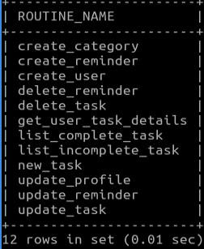

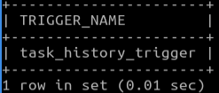

**DML Commands**

**Queries**

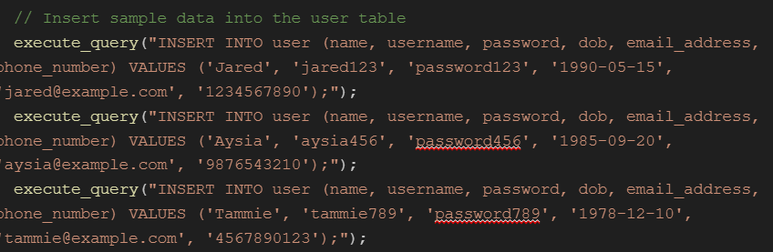

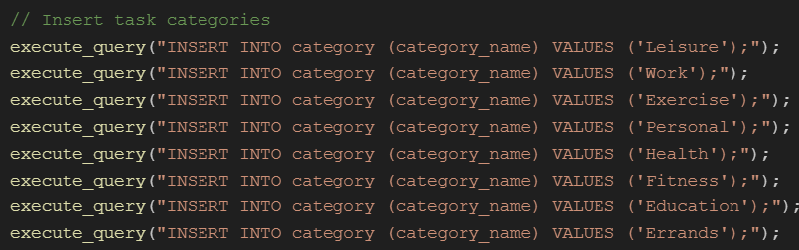

**Results**

